Therefore, according to our investigation, a 1.5L coke bottle actually has the volume of 1.5461L

Link to graph:

<https://www.desmos.com/calculator/spgicsyge0>

We used a total of 9 equations to graph the contour of a Coke bottle:

| **Equation** | **Limits** |
| --- | --- |
| $f_{1}(x)=0.75sin^{2}(0.87x)+0.335$ | $0 ≤ x ≤1.745$ |
| $f_{2}(x)=-0.15(x-2.17)^{2}+1.11$ | $1.745 ≤ x ≤2.17$ |
| $f_{3}(x)=0.01384(x-3.87)^{2}+1.07$ | $2.17 ≤ x ≤3.87$ |
| $f_{4}(x)= -0.12(x-3.87)^{2}+1.07$ | $3.87 ≤ x ≤4.8$ |
| $f_{5}(x)=0.102(x-5.2)^{2}+0.95$ | $4.8 ≤ x ≤5.2$ |
| $f_{6}(x)=0.3(x-5.2)^{2}+0.95$ | $5.2 ≤ x ≤5.681$ |
| $f_{7}(x)=-0.638(x-5.9)^{2}+1.05$ | $5.681 ≤ x ≤5.9$ |
| $g_{8}(y)=-3.65(y-0.5)^{2}+7$ | $0.5 ≤ y ≤1.05$ or $5.899 ≤ x ≤7$ |
| $g_{9}(y)=-2.564*(y-0.5)^{2} + 7$ | $0 ≤ y ≤0.5$ or $6.359 ≤ x ≤7$ |

We used the disk method to compute for the total area:

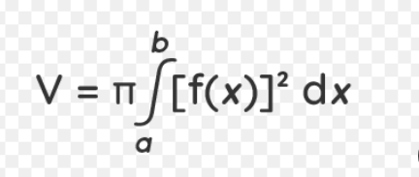

To compute this accurately with all the complex integrations and so on we used WxMaxima a CAS or Computer Algebra System.

This was the code

kill(all)$

load(draw)$

ratprint: false$

fpprintprec: 5$

/* First half of Coke Bottle Equations that are in terms of y */

eq1(x) := 0.75*sin(0.87*x)^2+0.335$

eq2(x) := -0.15*(x-2.17)^2+1.11$

eq3(x) := 0.01384*(x-3.87)^2+1.07$

eq4(x) := -0.12*(x-3.87)^2+1.07$

eq5(x) := 0.102*(x-5.2)^2+0.95$

eq6(x) := 0.3*(x-5.2)^2+0.95$

eq7(x) := -0.638*(x-5.9)^2+1.05$

/* Second half of Coke Bottle Equations that are in terms of x */

eq8(y) := -3.65*(y-0.5)^2+7$

eq9(y) := -2.564*(y-0.5)^2 + 7$

/* Convert the equations into terms of y and choose the variation that lines up with the graph*/

define(invEq8(x), rhs(solve(eq8(y) = x, y)[2])), numer$

define(invEq9(x), rhs(solve(eq9(y) = x, y)[1])), numer$

/* Solve for each equation's volume around the x-axis through the Disk Method */

v1 : %pi*integrate(eq1(x),x,0.,1.745)^2, numer;

v2 : %pi*integrate(eq2(x),x,1.745,2.17)^2, numer;

v3 : %pi*integrate(eq3(x),x,2.17,3.87)^2, numer;

v4 : %pi*integrate(eq4(x),x,3.87, 4.8)^2, numer;

v5 : %pi*integrate(eq5(x),x,4.8, 5.2)^2, numer;

v6 : %pi*integrate(eq6(x),x,5.2, 5.681)^2, numer;

v7 : %pi*integrate(eq7(x),x,5.681, 5.9)^2, numer;

v8 : %pi*integrate(invEq8(x),x,5.899, 7)^2, numer;

v9 : %pi*integrate(invEq9(x),x,6.359, 7)^2, numer;

/* Now we compute for the total volume */

vTotal : v1 + v2 + v3 + v4 +v5 + v6 + v7 + v8 - v9$ /* v8 - v9 gets the volume of the bottle's feet stands*/

inGraphHeight : 7.5$ /* Note we need to include the bottlecap height too */

actualHeight : 0.3048$ /* 1 foot in meters to keep things metric*/

/* By using the ratio we can compute for the actual volume according to the graph */

actualVTotal : float(vTotal * ((actualHeight / inGraphHeight)^3) * 1000), numer; /* x1000 to convert m^3 to L */

print("Therefore, according to our investigation, a 1.5L coke bottle actually has the volume of", actualVTotal,"L")$

/* Graphing the generated figure */

/* Create the surfaces of revolution */

surface1 : parametric_surface(eq1(x)*cos(theta), eq1(x)*sin(theta), x, x, 0,1.745, theta, 0, 2*%pi)$

surface2 : parametric_surface(eq2(x)*cos(theta), eq2(x)*sin(theta), x, x, 1.745,2.17, theta, 0, 2*%pi)$

surface3 : parametric_surface(eq3(x)*cos(theta), eq3(x)*sin(theta), x, x, 2.17,3.87, theta, 0, 2*%pi)$

surface4 : parametric_surface(eq4(x)*cos(theta), eq4(x)*sin(theta), x, x, 3.87, 4.8, theta, 0, 2*%pi)$

surface5 : parametric_surface(eq5(x)*cos(theta), eq5(x)*sin(theta), x, x, 4.8, 5.2, theta, 0, 2*%pi)$

surface6 : parametric_surface(eq6(x)*cos(theta), eq6(x)*sin(theta), x, x, 5.2, 5.681, theta, 0, 2*%pi)$

surface7 : parametric_surface(eq7(x)*cos(theta), eq7(x)*sin(theta), x, x, 5.681, 5.9, theta, 0, 2*%pi)$

surface8 : parametric_surface(invEq8(x)*cos(theta), invEq8(x)*sin(theta), x, x, 5.899, 7, theta, 0, 2*%pi)$

surface9 : parametric_surface(invEq9(x)*cos(theta), invEq9(x)*sin(theta), x, x, 6.359, 7, theta, 0, 2*%pi)$

/* Draw the surfaces */

draw3d(proportional_axes=xyz, color="red", surface1, surface2, surface3, surface4, surface5, surface6, surface7, surface8, surface9)$

With syntax highlighting:

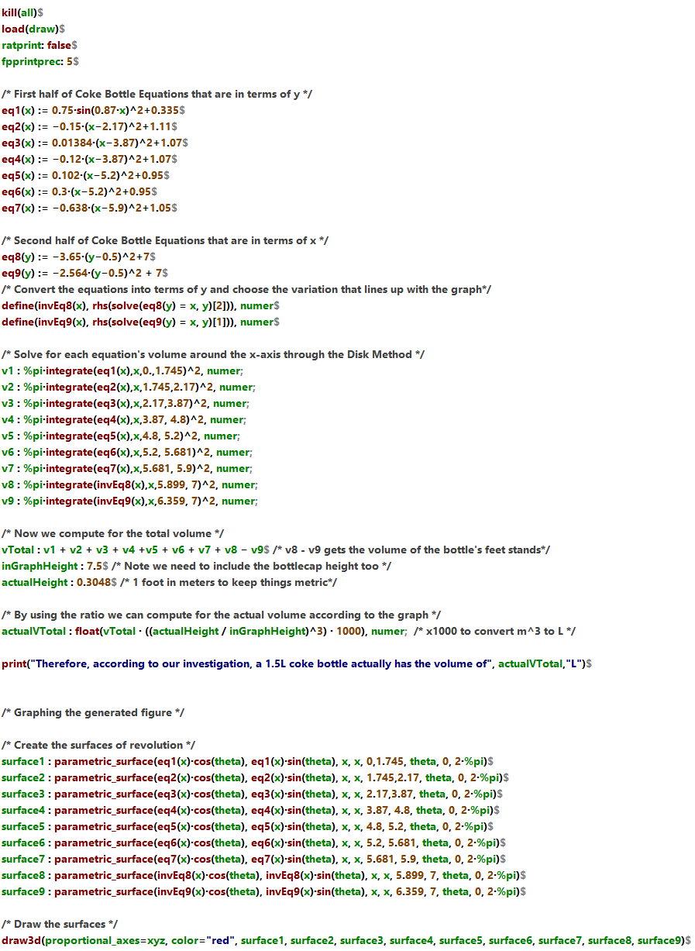

Output:

